**Design Idea Concept 4 – Digital healthcare system (Nguyen Nam Tung)**

## Learning issue:

In my previous individual report, I demonstrated that the learning issue relates to the Umuwa, South Australia health system. With a low life expectancy and a high hospitalization rate, the healthcare issues of indigenous region residents, particularly in Umuwa, are very problematic. Consequently, utilizing digital technology is one of the most effective and crucial means of addressing this issue. Our team intends to create a mobile application and use a technological watch to monitor and assess the health of Umuwa residents. In this section, I will explain how the technology functions, how it is implemented, and what issues are associated with its use.

## Design concept:

1. Design outline

A combination of a smartwatch and a software application is utilized to address health issues in Umuwa. They are technological devices that are interconnected and should not be used independently. The smartwatch uses a highly specialized sensor that can monitor the user's heart rate, calories burned, quality of sleep, blood pressure, temperature, and more... These statistics are then sent to the mobile application, which evaluates the information and sends it back to the users. This electronic health report will include all statistics, with particular emphasis on negative health indicators. It will also include some recommendations for addressing the health issues, such as setting up a suitable exercise routine and diet. Additionally, a replica of the medical report will be sent to the database of the local health service centre to improve the quality of medical examinations as the doctors can use it to predict the health condition of the patient in the future. The copy will also be sent from the local database to the central database of the Australian medical department as a reliable source of data for long-term campaigns aimed at resolving rural and indigenous health issues.

1. Design Specifications - List of hardware and software requirements

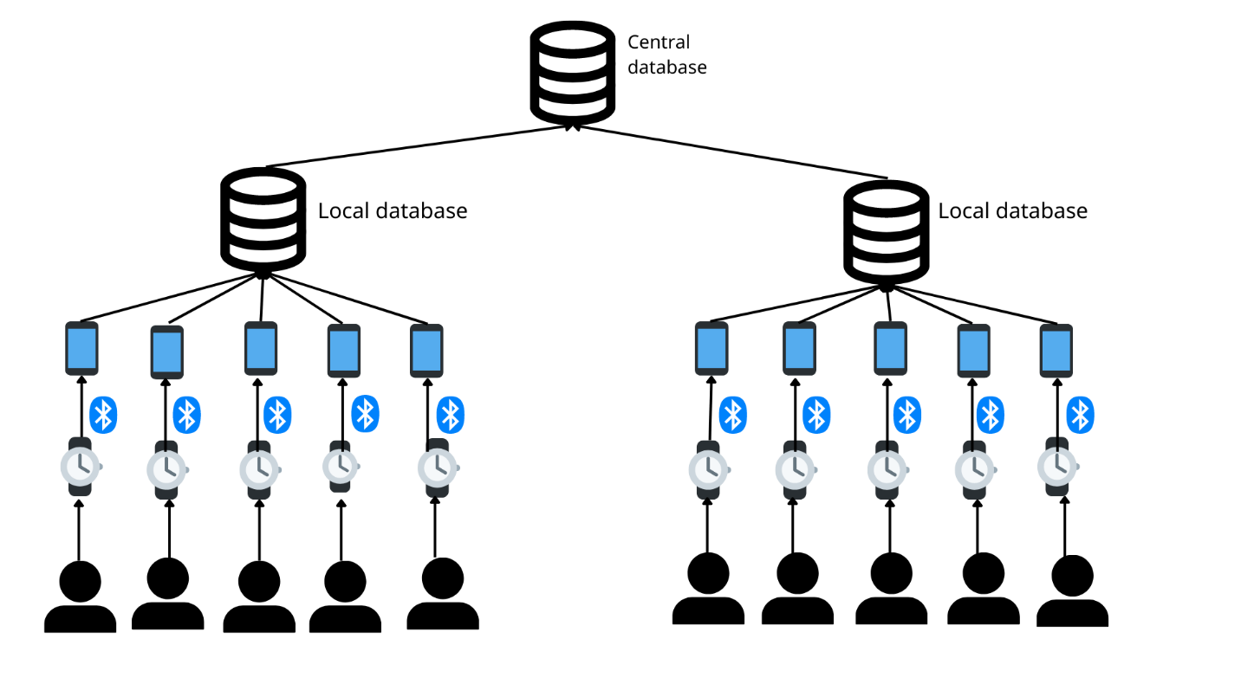

The aforementioned diagram illustrates how my digital healthcare system functions (this serves as a summary of the previous design outline), but more specifically how the connections have been established and what software is employed to set up the system.

**Software requirements:**

Health-tracking application

As an intermediary between the local database and the users' smartwatches, the health-tracking application is one of the most important aspects of this system. In addition to reporting statistics to users and the local health centre (the local database), it can be configured with a microphone for voice or video calls. This feature can be implemented to establish an online connection between the users and the doctors in the local medical centre, allowing the users to receive assistance and advice from the doctors if they experience any health issues. This application also allows for the online scheduling of medical examinations at the clinic. This is an example of how the software may look:

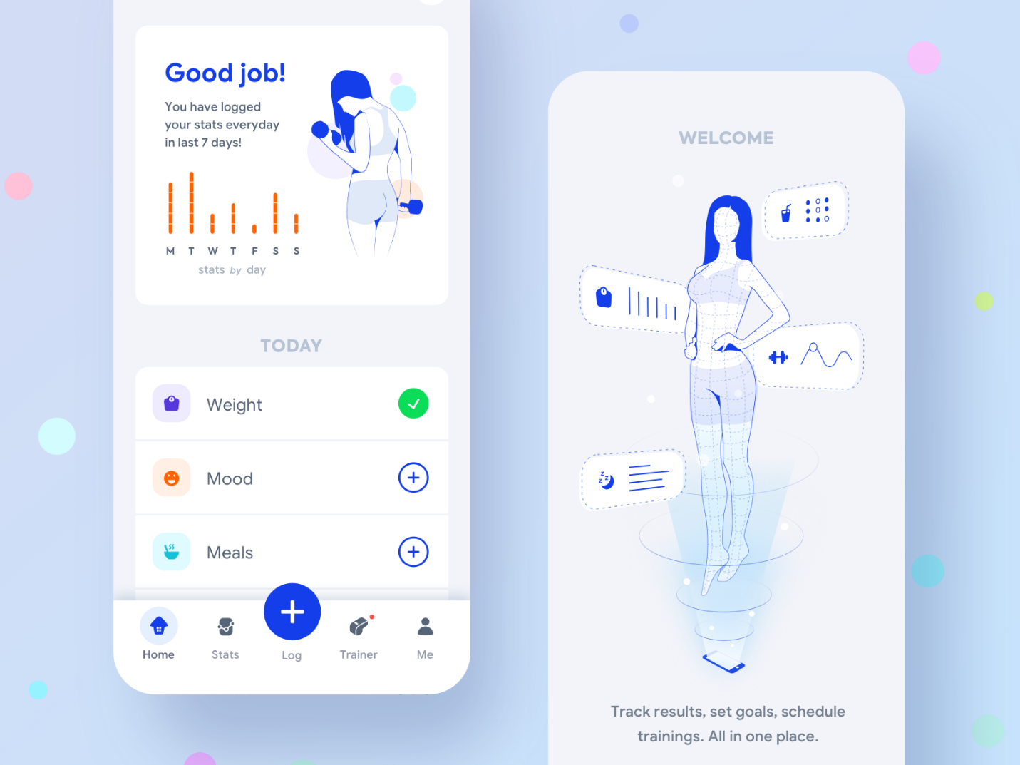

Figure 7: Health-tracking application (Paterska, 2022)

Database

A database is a collection of data that is maintained and stored for a particular purpose. In this instance, the medical information of the users is stored in a database, and doctors will use this information to monitor patient health and make recommendations.

**Hardware requirements:**

Phone

The health application requires a smartphone to download. The application is compatible with a wide variety of phones, but Apple's IOS 14.4 or later is required for compatibility. Other smartphones using the Android operating system should have at least version 2.2.3.

Smartwatch

A smartwatch is used to collect the user's health data. The smartwatch must be able to connect to the smartphone via Bluetooth. It should look similar to this design:

Figure 8: A standard smartwatch

**Connection requirements:**

Bluetooth connection

The Bluetooth connection must always be established from the phone to the watch. This link should never be disabled for a more precise data-collection process.

Database connection

The smartphone should have a connection to the database of the nearby medical centre. Additionally, this database should also be linked to the central database.

Internet connection

Internet connection is still very vital in this health system, but speed is not a big problem. A speed of 14.4 kbps (kilobit per second, which is the rate used to surf the internet, and email writing is good enough for basic and casual usage of the application. Only if online meetings with the doctors are conducted, the speed of 28.8 kbps will be utilized.

## Design benefits

Many people around the world have adopted the use of smartwatches and health-tracking applications, particularly those who have a workout routine, are seeking a healthy lifestyle, or have recently recovered from an illness. It has not been implemented in any rural areas. Despite this, I believe that the design concept of the Umuwa /South Australia digital health system provides a multitude of substantial benefits to the remote and indigenous community, meeting the digital communication principles standards.

1. Accessible to all people

Because only a single phone is required to monitor the health status of an entire family, this technology is applicable to all special cases, such as children, the elderly, and the disabled. They only need to wear the watches for information to be gathered. The coverage area of this technology is also large, allowing all residents of Umuwa to have access to it.

1. Health

According to several sources, the radiation emitted by smartwatches can be harmful to citizens' health. But the censor's working principle is to use spectroscopy to detect reflected light and evaluate the heartbeat, allowing it to measure our heartbeat and other statistics, so it does not have any impact on the users (O'Donoghue, 2021).

1. No impacts on the environment

This technology is friendly to the environment. This technology does not emit any chemical substances or radiation that could be harmful to the environment.

1. Affordability and maintenance

There is no large equipment such as a radar or an antenna, only a wireless connection. In addition, this system can be used for a very long time, which eliminates the need for routine technology inspections and maintenance, thereby reducing costs. The fact that these two devices are not in a niche market also contributes to their lower price. The products are not unique, and there are a great number of suppliers of smartphones and smartwatches, so there are numerous choices for selecting the most cost-effective suppliers.

## Design Constraints

Although the design brings ample advantages, throughout the process of implementing this project, some potential challenges might still be encountered.

1. Workforce skills:

Operating and managing digital health devices and databases requires a great deal of technical skills in addition to traditional medical expertise. Therefore, training courses on the proper administration and use of the devices must be provided to the doctors, which can take some time to accomplish.

1. Citizen’s adaptability

It has been difficult for rural communities to keep up with digital developments. (Koen Salemink, 2017). This is due not only to the high cost and limited availability of infrastructure but also to the inability of rural residents, especially in indigenous regions, to adapt to the use and evolution of technology. Many rural residents continue to doubt technological devices for superstitious reasons. Some individuals do not, but they do not know how to use smart technological devices such as smartphones and smartwatches properly. As a result, some basic instructions on how to use the health application and the gadgets must be given, which may last a couple of weeks.

Reference:

Koen Salemink, D. S., Gary Bosworth (2017). Rural development in the digital age: A systematic literature review on unequal ICT availability, adoption, and use in rural areas. <https://www.sciencedirect.com/science/article/abs/pii/S0743016715300176>

O'Donoghue, J. (2021). *I ‘heart’ my smartwatch*. <https://edu.rsc.org/feature/the-science-of-smartwatches/4013008.article>

Paterska, P. (2022). *7 Ideas for Healthcare Apps the World Still Needs (Updated)*. <https://www.elpassion.com/blog/4-ideas-for-a-healthcare-app-the-world-still-needs>